Oneida Lake Marina OLM #26-11
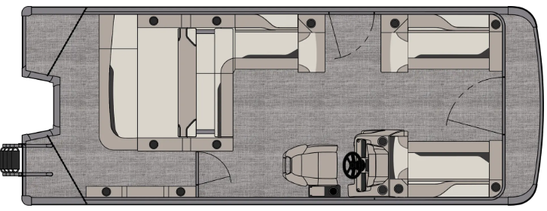
3713 State Route 31 Canastota, NY 13032

(315) 697-4867 Fax (315) 697-4868
www.oneidalakemarina.com
email: oneidalakemarina@gmail.com

2026 21’ Tahoe Sport VRB Tri-toon
(8’ Wide - 21’ Deck) – ( $42,428.00)
w/Yamaha VF150 SHO EFI 4-Stroke
($18,250.00)
Black Walls, Graphite & Silver Interior, w/Black Accents,
& Charcoal Canvas
ADDED OPTIONS INCLUDED IN THIS PRICE:
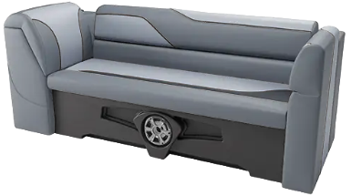
Sport Performance 25” Tri-toon Package
Black-out Package
Electric Bimini (Black)
90 Degree Smoked Chrome Docklights
Garmin 52CV GPS
Charcoal Seat Cladding w/SS Inserts
Starboard Low Back Chair w/Arms
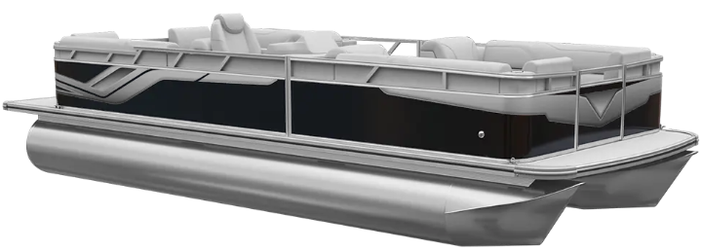
Riptide Shadow Flooring
Ontario Steering Wheel
U-Flex Protech Steering
Privacy Station Rail and Curtain
Individual Seat Covers
Stainless Steel Aft Rail
Ski Tow Bar

ONEIDA LAKE MARINA SALE PRICE
$60,678.00+ Tax & Reg
MSRP: $76,167.63
PRICE INCLUDES: Free Local Delivery, Complete Coast Guard Kit, Freight/Prep, & Full Tank of Fuel

Optional Trailer Pricing:
Load Rite P20/22T 4100TriB1 $6,100.00
(Galvanized, Dual Axle, Dual Brake, 4100lb. Capacity w/Tri-toon Kit)

Boat – DVN73517G526
Motor – 1015458

