Oneida Lake Marina OLM #26-12
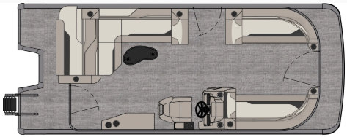
3713 State Route 31 Canastota, NY 13032

(315) 697-4867 Fax (315) 697-4868
www.oneidalakemarina.com
email: oneidalakemarina@gmail.com

2026 21’ Tahoe Sport 85 Cruise Rear Bench
(8 1/2’ Wide - 23’ Deck) – ( $29,867.00)
w/Honda BF100L EFI 4-Stroke
($10,550.00)
Champagne Walls, Buckskin & Cream White Interior, w/Black Accents, & Black Canvas

ADDED OPTIONS INCLUDED IN THIS PRICE:

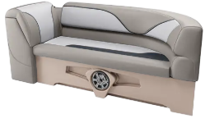

Starboard Sport Low Back Chair w/Arms
Buckskin Seat Cladding
Ontario Steering Wheel
Uflex Mechanical Tilt Steering
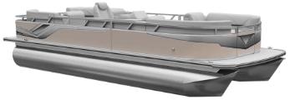
Riptide Shadow Flooring
Privacy Station Rail and Curtain
Individual Seat Covers
Exterior Nav/Dock Lights
2’ Rear Patio Pad

ONEIDA LAKE MARINA SALE PRICE
$40,417.00+ Tax & Reg
MSRP: $48,901.56

PRICE INCLUDES: Free Local Delivery, Complete Coast Guard Kit, Freight/Prep, & Full Tank of Fuel

Optional Trailer Pricing:
Load Rite P22/24T 3000T $4,800.00
(Galvanized, Dual Axle, No Brake, 3000lb. Capacity)

Boat – DVN73520G526
Motor – BBMJ-1125568

