Oneida Lake Marina OLM #26-15
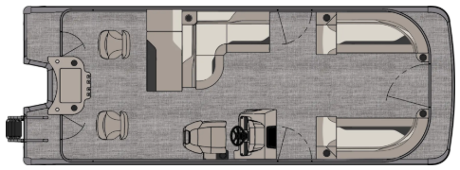
3713 State Route 31 Canastota, NY 13032

(315) 697-4867 Fax (315) 697-4868
www.oneidalakemarina.com
email: oneidalakemarina@gmail.com

2026 23’ Tahoe Sport 85 Rear Fish Tri-Toon
(8 1/2’ Wide - 23’ Deck) – ( $44,823.00)
w/Honda BF150 EFI 4-Stroke
($14,850.00)
Charcoal Matte Walls, Graphite & Silver Interior, w/Charcoal Accents, & Black Canvas

ADDED OPTIONS INCLUDED IN THIS PRICE:

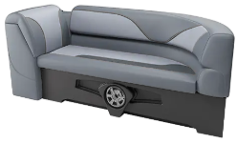
Sport Performance Package w/ Triple 25 Inch Pontoons
2 Starboard Low Back w/Arms in Place of Fishing Chairs
Starboard Sport Low Back Captain’s Chair w/Arms
Charcoal Seat Cladding w/SS Inserts
Livewell In Place Of Sundeck
Blackout Package
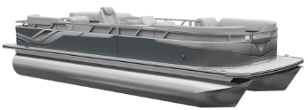
Ontario Steering Wheel
Uflex Protech Steering
Riptide Shadow Flooring
Privacy Station Rail and Curtain
Individual Seat Covers
Smoked Chrome Docklight Assy
Lillipad Easy Step Ladder
Garmin 72SV US
ONEIDA LAKE MARINA SALE PRICE
$59,673.00+ Tax & Reg
MSRP: $71,743.75

PRICE INCLUDES: Free Local Delivery, Complete Coast Guard Kit, Freight/Prep, & Full Tank of Fuel

Optional Trailer Pricing:
Load Rite P22/24T 4700TriB1 $6,450.00
(Galvanized, Dual Axle, Dual Brake, 4700lb. Capacity w/Tri-toon Kit)

Boat – DVN73527G526
Motor –

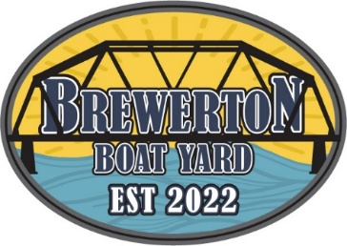
#26-15

2026 23’ Tahoe Sport 85 Rear Fish Tri-Toon
(8 1/2’ Wide - 23’ Deck) – ( $44,823.00)
w/Honda BF150XL EFI 4-Stroke
($14,850.00)
Charcoal Matte Walls, Graphite & Silver Interior, w/Charcoal Accents, & Black Canvas

ADDED OPTIONS INCLUDED IN THIS PRICE:

Sport Performance Package w/ Triple 25 Inch Pontoons
2 Starboard Low Back w/Arms in Place of Fishing Chairs
Starboard Sport Low Back Captain’s Chair w/Arms
Charcoal Seat Cladding w/SS Inserts
Livewell In Place Of Sundeck
Blackout Package
Ontario Steering Wheel
Uflex Protech Steering
Riptide Shadow Flooring
Privacy Station Rail and Curtain
Individual Seat Covers
Smoked Chrome Docklight Assy
Lillipad Easy Step Ladder
Garmin 72SV US
ONEIDA LAKE MARINA SALE PRICE
$59,673.00+ Tax & Reg
MSRP: $71,743.75

PRICE INCLUDES: Free Local Delivery, Complete Coast Guard Kit, Freight/Prep, & Full Tank of Fuel

Optional Trailer Pricing:
Load Rite P22/24T 4700TriB1 $6,450.00
(Galvanized, Dual Axle, Dual Brake, 4700lb. Capacity w/Tri-toon Kit)

Boat – DVN73527G526
Motor – BBTJ-1009272

