Oneida Lake Marina OLM #26-16
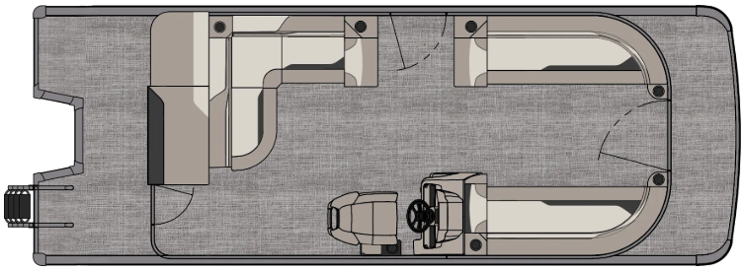
3713 State Route 31 Canastota, NY 13032

(315) 697-4867 Fax (315) 697-4868
www.oneidalakemarina.com
email: oneidalakemarina@gmail.com

2026 23’ Tahoe Sport 85 Cruise
(8 1/2’ Wide - 23’ Deck) – ( $29,375.00)
w/Honda BF140L White EFI 4-Stroke
($13,000.00)
White Flake Matte Walls, Silver & Graphite Interior, w/Charcoal Accents, & Charcoal Canvas

ADDED OPTIONS INCLUDED IN THIS PRICE:

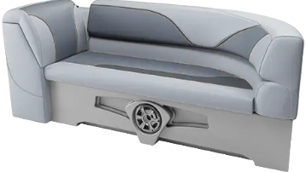

Starboard Sport Low Back Chair w/Arms
Silver Seat Cladding
Uflex Hyco Steering
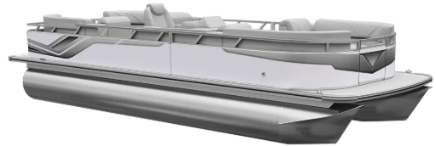
Riptide Shadow Flooring
Privacy Station Rail and Curtain
Individual Seat Covers
Exterior Nav/Dock Lights
Ontario Steering Wheel

ONEIDA LAKE MARINA SALE PRICE
$42,375.00+ Tax & Reg
MSRP: $49,545.31

PRICE INCLUDES: Free Local Delivery, Complete Coast Guard Kit, Freight/Prep, & Full Tank of Fuel

Optional Trailer Pricing:
Load Rite P22/24T 3000T $4,800.00
(Galvanized, Dual Axle, No Brake, 3000lb. Capacity)

Boat – DVN73530G526
Motor – BBUJ-

OLM #26-16
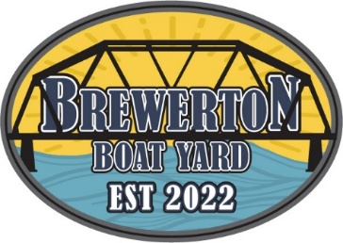

2026 23’ Tahoe Sport 85 Cruise
(8 1/2’ Wide - 23’ Deck) – ( $29,375.00)
w/Honda BF140L White EFI 4-Stroke
($13,000.00)
White Flake Matte Walls, Silver & Graphite Interior, w/Charcoal Accents, & Charcoal Canvas

ADDED OPTIONS INCLUDED IN THIS PRICE:

Starboard Sport Low Back Chair w/Arms
Silver Seat Cladding
Uflex Hyco Steering
Riptide Shadow Flooring
Privacy Station Rail and Curtain
Individual Seat Covers
Exterior Nav/Dock Lights
Ontario Steering Wheel

ONEIDA LAKE MARINA SALE PRICE
$42,375.00+ Tax & Reg
MSRP: $49,545.31

PRICE INCLUDES: Free Local Delivery, Complete Coast Guard Kit, Freight/Prep, & Full Tank of Fuel

Optional Trailer Pricing:
Load Rite P22/24T 3000T $4,800.00
(Galvanized, Dual Axle, No Brake, 3000lb. Capacity)

Boat – DVN73530G526
Motor – BBUJ-

