Oneida Lake Marina OLM #26-17
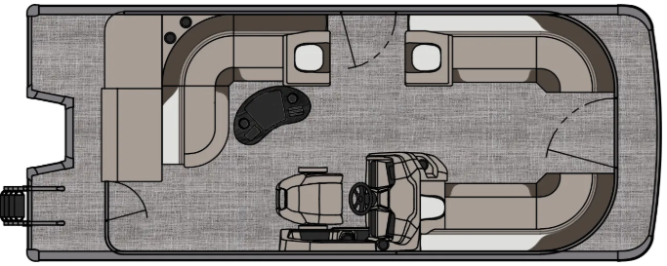
3713 State Route 31 Canastota, NY 13032

(315) 697-4867 Fax (315) 697-4868
www.oneidalakemarina.com
email: oneidalakemarina@gmail.com

2026 21’ Tahoe LTZ Cruise
(8 ½’ Wide - 21’ Deck) – ( $34,085.00)
w/Honda BF115L EFI 4-Stroke
($11,950.00)
Caribbean Blue & White Flake Metallic Walls, Cream White & Buckskin Interior, w/Caribbean Blue Accents, & Charcoal Canvas
ADDED OPTIONS INCLUDED IN THIS PRICE:
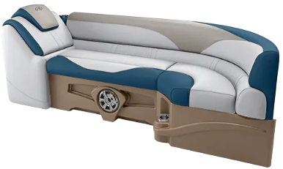
Starboard Sport High Back Reclining Chair
Ultrafine Vinyl Upgrade
Riptide Shadow Flooring
Blue Ice Light Package
Uflex Mechanical Tilt Steering
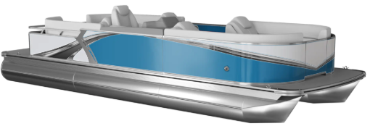
Privacy Station Rail and Curtain
Individual Seat Covers
Smoked Chrome Docklight Assy
Brushed Bronze Seat Cladding
Stainless Cladding Inserts
Polished Corner Caps
Lillipad Easy Step Ladder

ONEIDA LAKE MARINA SALE PRICE
$46,035.00+ Tax & Reg
MSRP: $54,746.88

PRICE INCLUDES: Free Local Delivery, Complete Coast Guard Kit, Freight/Prep, & Full Tank of Fuel

Optional Trailer Pricing:
Load Rite P20/22 2750T $3,800.00
(Galvanized, Single Axle, No Brake, 2750lb. Capacity)

Boat – DVN73532G526
Motor – BBWJ-1100403

