Oneida Lake Marina OLM #26-20
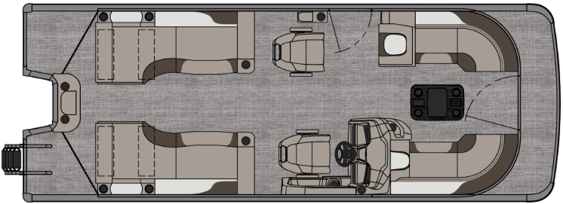
3713 State Route 31 Canastota, NY 13032

(315) 697-4867 Fax (315) 697-4868
www.oneidalakemarina.com
email: oneidalakemarina@gmail.com

2026 23’ Tahoe LTZ Quad Lounge Shift
(8 ½’ Wide - 23’ Deck) – ( $43,927.00)
w/Honda BF140 EFI 4-Stroke
($12,750.00)
Charcoal Matte & Black Walls, Graphite & Silver Interior, w/Charcoal Accents, & Charcoal Canvas

ADDED OPTIONS INCLUDED IN THIS PRICE:

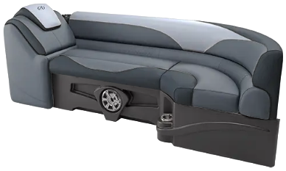
Port & Starboard Sport High Back Reclining Chair
Ultra Fine Vinyl Upgrade
Charcoal Seat Cladding w/SS Inserts
Garmin 52CV US GPS
Uflex Hyco Steering
Riptide Shadow Flooring
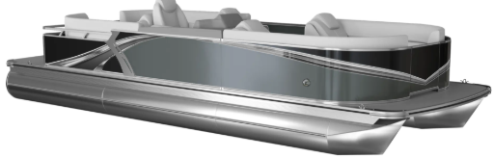
Blackout Package
Lillipad Easy Step Ladder
Smoked Chrome Docklight Assy
Privacy Station Rail and Curtain
Individual Seat Covers
Blue Ice Light Package

ONEIDA LAKE MARINA SALE PRICE
$56,677.00+ Tax & Reg
MSRP: $68,821.88

PRICE INCLUDES: Free Local Delivery, Complete Coast Guard Kit, Freight/Prep, & Full Tank of Fuel

Optional Trailer Pricing:
Load Rite P22/24T 3000T $4,800.00
(Galvanized, Dual Axle, No Brake, 3000lb. Capacity)

Boat – DVN73537G526
Motor – BBUJ-1100066

