Oneida Lake Marina OLM #26-22
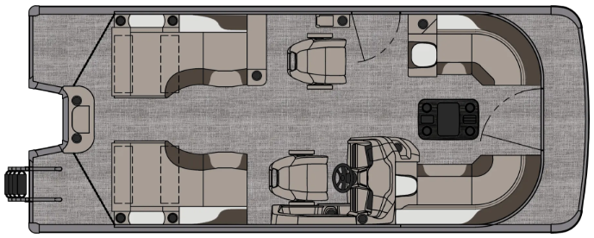
3713 State Route 31 Canastota, NY 13032

(315) 697-4867 Fax (315) 697-4868
www.oneidalakemarina.com
email: oneidalakemarina@gmail.com

2026 21’ Tahoe LTZ Quad Lounge Shift
(8 ½’ Wide - 21’ Deck) – ( $39,509.00)
w/Honda BF115 EFI 4-Stroke
($11,950.00)
Champagne & Black Walls, Buckskin & Cream White Interior, w/Black Accents, & Black Canvas

ADDED OPTIONS INCLUDED IN THIS PRICE:

Port & Starboard Sport High Back Reclining Chair
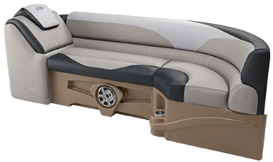
Ultra Fine Vinyl Upgrade
Brushed Bronze Seat Cladding w/SS Inserts
Garmin 52CV US GPS
Uflex Mechanical Tilt Steering
Riptide Shadow Flooring
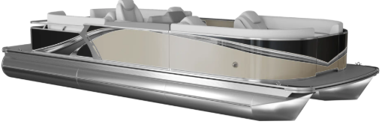
Blackout Package
Ski Tow Bar w/Chained Aft
Smoked Chrome Docklight Assy
Privacy Station Rail and Curtain
Individual Seat Covers
Blue Ice Light Package
Ski Tow Bar & Chained Aft

ONEIDA LAKE MARINA SALE PRICE
$51,459.00+ Tax & Reg
MSRP: $62,067.19

PRICE INCLUDES: Free Local Delivery, Complete Coast Guard Kit, Freight/Prep, & Full Tank of Fuel

Optional Trailer Pricing:
Load Rite P20/22 2750T $3,800.00
(Galvanized, Single Axle, No Brake, 2750lb. Capacity)

Boat – DVN73540G526
Motor – BBWJ-1100398

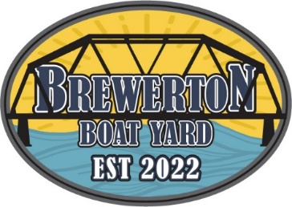
OLM #26-22

2026 21’ Tahoe LTZ Quad Lounge Shift
(8 ½’ Wide - 21’ Deck) – ( $39,509.00)
w/Honda BF115 EFI 4-Stroke
($11,950.00)
Champagne & Black Walls, Buckskin & Cream White Interior, w/Black Accents, & Black Canvas

ADDED OPTIONS INCLUDED IN THIS PRICE:

Port & Starboard Sport High Back Reclining Chair
Ultra Fine Vinyl Upgrade
Brushed Bronze Seat Cladding w/SS Inserts
Garmin 52CV US GPS
Uflex Mechanical Tilt Steering
Riptide Shadow Flooring
Blackout Package
Ski Tow Bar w/Chained Aft
Smoked Chrome Docklight Assy
Privacy Station Rail and Curtain
Individual Seat Covers
Blue Ice Light Package
Ski Tow Bar & Chained Aft

ONEIDA LAKE MARINA SALE PRICE
$51,459.00+ Tax & Reg
MSRP: $62,067.19

PRICE INCLUDES: Free Local Delivery, Complete Coast Guard Kit, Freight/Prep, & Full Tank of Fuel

Optional Trailer Pricing:
Load Rite P20/22 2750T $3,800.00
(Galvanized, Single Axle, No Brake, 2750lb. Capacity)

Boat – DVN73540G526
Motor – BBWJ-1100398

