Oneida Lake Marina OLM #26-24
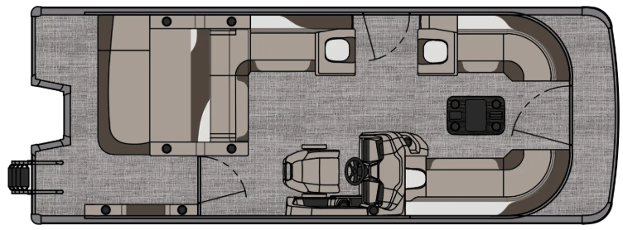
3713 State Route 31 Canastota, NY 13032

(315) 697-4867 Fax (315) 697-4868
www.oneidalakemarina.com
email: oneidalakemarina@gmail.com

2026 23’ Tahoe LTZ VRB
(8 ½’ Wide - 23’ Deck) – ( $40,269.00)
w/Honda BF140 White EFI 4-Stroke
($13,350.00)
Bronze & White Flake Metallic Walls, Cream White & Buckskin Interior, w/Champagne Beige Accents, & Black Canvas

ADDED OPTIONS INCLUDED IN THIS PRICE:

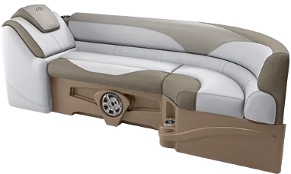
Port & Starboard Sport High Back Reclining Chair (Above Picture does not depict this option)
Ultra Fine Vinyl Upgrade
Brushed Bronze Seat Cladding w/SS Inserts
Garmin 52CV US GPS
Uflex Hyco Steering
Riptide Shadow Flooring
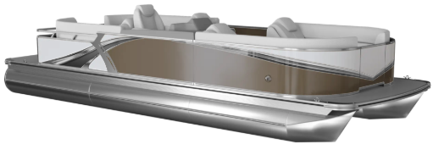
Polished Corner Caps
Lillipad Easy Step Ladder
Smoked Chrome Docklight Assy
Privacy Station Rail and Curtain
Individual Seat Covers
Stainless Steel Aft Rail

ONEIDA LAKE MARINA SALE PRICE
$53,619.00+ Tax & Reg
MSRP: $63,946.88

PRICE INCLUDES: Free Local Delivery, Complete Coast Guard Kit, Freight/Prep, & Full Tank of Fuel

Optional Trailer Pricing:
Load Rite P22/24T 3000T $4,800.00
(Galvanized, Dual Axle, No Brake, 3000lb. Capacity)

Boat – DVN73542G526
Motor –

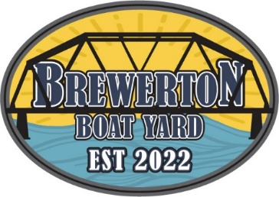
#26-24

2026 23’ Tahoe LTZ VRB
(8 ½’ Wide - 23’ Deck) – ( $40,269.00)
w/Honda BF140 White EFI 4-Stroke
($13,350.00)
Bronze & White Flake Metallic Walls, Cream White & Buckskin Interior, w/Champagne Beige Accents, & Black Canvas

ADDED OPTIONS INCLUDED IN THIS PRICE:

Port & Starboard Sport High Back Reclining Chair (Above Picture does not depict this option)
Ultra Fine Vinyl Upgrade
Brushed Bronze Seat Cladding w/SS Inserts
Garmin 52CV US GPS
Uflex Hyco Steering
Riptide Shadow Flooring
Polished Corner Caps
Lillipad Easy Step Ladder
Smoked Chrome Docklight Assy
Privacy Station Rail and Curtain
Individual Seat Covers
Stainless Steel Aft Rail

ONEIDA LAKE MARINA SALE PRICE
$53,619.00+ Tax & Reg
MSRP: $63,946.88

PRICE INCLUDES: Free Local Delivery, Complete Coast Guard Kit, Freight/Prep, & Full Tank of Fuel

Optional Trailer Pricing:
Load Rite P22/24T 3000T $4,800.00
(Galvanized, Dual Axle, No Brake, 3000lb. Capacity)

Boat – DVN73542G526
Motor –

