Oneida Lake Marina OLM #26-25
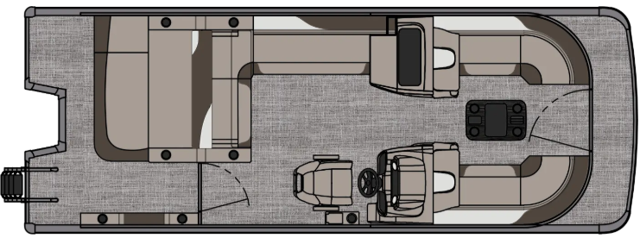
3713 State Route 31 Canastota, NY 13032

(315) 697-4867 Fax (315) 697-4868
www.oneidalakemarina.com
email: oneidalakemarina@gmail.com

2026 23’ Tahoe LTZ VRB Tri-toon
(8 ½’ Wide - 23’ Deck) – ( $54,694.00)
w/Honda BF200 EFI 4-Stroke
($19,500.00)
Charcoal Matte & Champagne Walls, Buckskin & Cream White Interior, w/Charcoal Accents, & Charcoal Canvas
ADDED OPTIONS INCLUDED IN THIS PRICE:
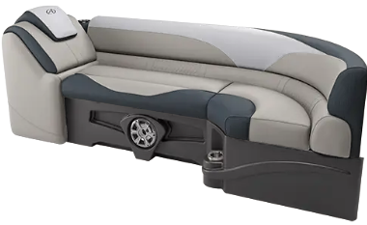
Starboard Sport High Back Reclining Chair
Sport Performance Tri-toon Package
Ultra Fine Vinyl Upgrade
Blue Ice Plus Light Package
Charcoal Seat Cladding w/SS Inserts
Garmin 52CV US GPS
Uflex Protech Steering
Riptide Shadow Flooring
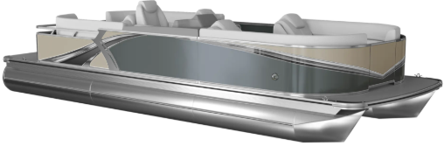
Blackout Package
Lillipad Easy Step Ladder
Smoked Chrome Docklight Assy
Privacy Station Rail and Curtain
Individual Seat Covers
Stainless Steel Aft Rail
2’ Rear Patio Pad & Half Enclosure
ONEIDA LAKE MARINA SALE PRICE
$74,194.00+ Tax & Reg
MSRP: $88,728.13
PRICE INCLUDES: Free Local Delivery, Complete Coast Guard Kit, Freight/Prep, & Full Tank of Fuel

Optional Trailer Pricing:
Load Rite P24/26T 5000TriB1 $7,050.00
(Galvanized, Dual Axle, Dual Brake, 5000lb. Capacity)

Boat – DVN73544G526
Motor –

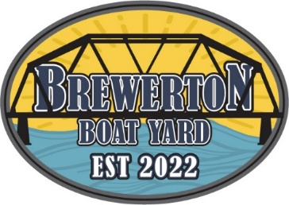
#26-25

2026 23’ Tahoe LTZ VRB Tri-toon
(8 ½’ Wide - 23’ Deck) – ( $54,694.00)
w/Honda BF200 EFI 4-Stroke
($19,500.00)
Charcoal Matte & Champagne Walls, Buckskin & Cream White Interior, w/Charcoal Accents, & Charcoal Canvas
ADDED OPTIONS INCLUDED IN THIS PRICE:
Starboard Sport High Back Reclining Chair
Sport Performance Tri-toon Package
Ultra Fine Vinyl Upgrade
Blue Ice Plus Light Package
Charcoal Seat Cladding w/SS Inserts
Garmin 52CV US GPS
Uflex Protech Steering
Riptide Shadow Flooring
Blackout Package
Lillipad Easy Step Ladder
Smoked Chrome Docklight Assy
Privacy Station Rail and Curtain
Individual Seat Covers
Stainless Steel Aft Rail
2’ Rear Patio Pad & Half Enclosure
ONEIDA LAKE MARINA SALE PRICE
$74,194.00+ Tax & Reg
MSRP: $88,728.13
PRICE INCLUDES: Free Local Delivery, Complete Coast Guard Kit, Freight/Prep, & Full Tank of Fuel

Optional Trailer Pricing:
Load Rite P24/26T 5000TriB1 $7,050.00
(Galvanized, Dual Axle, Dual Brake, 5000lb. Capacity)

Boat – DVN73544G526
Motor –

