Oneida Lake Marina OLM #26-29
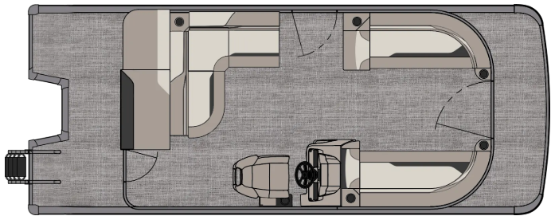
3713 State Route 31 Canastota, NY 13032

(315) 697-4867 Fax (315) 697-4868
www.oneidalakemarina.com
email: oneidalakemarina@gmail.com

2026 21’ Tahoe Sport 85 Cruise Bow Fish
(8 ½’ Wide - 23’ Deck) – ( $30,160.00)
w/Honda BF115XL EFI 4-Stroke
($12,300.00)
Black Walls, Graphite & Silver Interior, w/Black Accents, & Black Canvas

ADDED OPTIONS INCLUDED IN THIS PRICE:
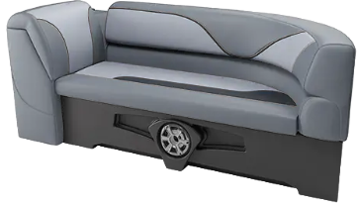

Starboard Low Back Chair w/Arms
Exterior Nav/Docklights
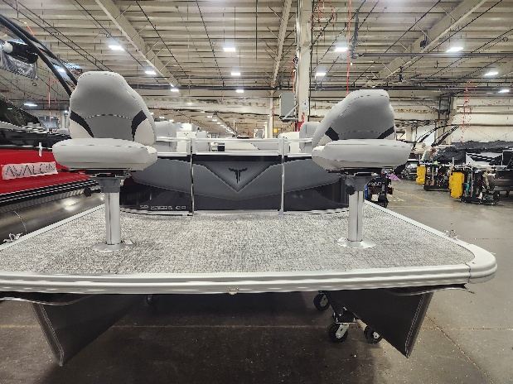
Charcoal Seat Cladding
Riptide Shadow Flooring
Uflex Mechanical Tilt Steering
Privacy Station Rail and Curtain
Individual Seat Covers
Garmin 52CV US
2’ Bow Deck Extension
2 Bow Fishing Chairs

ONEIDA LAKE MARINA SALE PRICE
$42,460.00+ Tax & Reg
MSRP: $49,492.19

PRICE INCLUDES: Free Local Delivery, Complete Coast Guard Kit, Freight/Prep, & Full Tank of Fuel

Optional Trailer Pricing:
Load Rite P20/22 2750T $3,800.00
(Galvanized, Single Axle, No Brake, 2750lb. Capacity)

Boat – DVN73552G526
Motor – BBWJ-1100094

