Oneida Lake Marina OLM #26-14
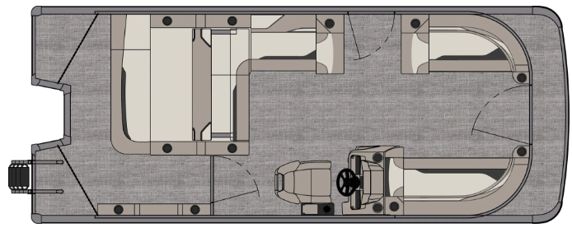
3713 State Route 31 Canastota, NY 13032

(315) 697-4867 Fax (315) 697-4868
www.oneidalakemarina.com
email: oneidalakemarina@gmail.com

2026 21’ Tahoe Sport 85 VRB
(8 ½’ Wide - 21’ Deck) – ( $30,340.00)
w/Honda BF100 EFI 4-Stroke
($10,550.00)
Bronze Walls, Cream White & Cognac Interior, w/Black Accents,
& Black Canvas
ADDED OPTIONS INCLUDED IN THIS PRICE:
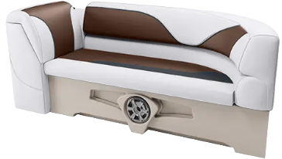

Exterior Nav/Docklights
White Seat Cladding
Starboard Low Back Chair w/Arms
Riptide Shadow Flooring
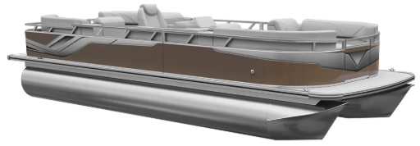
Ontario Steering Wheel
Uflex Mechanical Tilt Steering
Privacy Station Rail and Curtain
Individual Seat Covers
Stainless Steel Aft Rail

ONEIDA LAKE MARINA SALE PRICE
$40,890.00+ Tax & Reg
MSRP: $49,503.13

PRICE INCLUDES: Free Local Delivery, Complete Coast Guard Kit, Freight/Prep, & Full Tank of Fuel

Optional Trailer Pricing:
Load Rite P20/22 2750T $3,800.00
(Galvanized, Single Axle, No Brake, 2750lb. Capacity)

Boat – DVN73524G526
Motor – BBMJ-1126271

